**Project Report**



**Voice Based Email Service for visually**

**challenged people**

**BY-**

**Name: ADITYA GOPAL**

**Section: DS**

**University Roll No.: 2015046**

Department of Computer Science and Engineering

GEU Dehradun

**Contents:**

* 1. Abstract
  2. Introduction
  3. Problem Statement
  4. Motivation
  5. Software Requirements
  6. Hardware Requirements
  7. Language used
  8. Flowchart
  9. Libraries used
  10. Code Explanation
  11. Conclusion

**1.1 Abstract**

We have seen that how today Internet has changed everything around us which completely changed the meaning of many fields. Internet has made life of people so easy that today anyone can access any information they want sitting at their home. One field in which Internet helped a lot is communication. Listening communication over Internet, the thing pop in our mind is E-mails. Before Internet sending and receiving letter was common, but after Internet E-mails came into the picture. There is special criteria for humans to access E-mails and criteria is that they must be able to see. Now this can become very challenging for visually challenged people to access E-mails and we cannot leave this group of people around the globe.

Visually challenged people cannot use keyboard all they can do is they can give voice command for their work. Now we can make a model that can use their voice to send or read E-Mails.

**1.2 Introduction:**

In this project we will develop voice based email service for visually challenged people that can help them to send email to particular mail id given by them by just speaking and can also read new mail from their inbox.

This whole process i.e. sending mail and reading new mail from inbox completely done by just speaking and avoiding the use of keyboard at all.

**1.3 Problem Statement**

Voice based Email service for visually challenged people:

The main benefit of this system is that the use of keyboard is completely eliminated, the user will have to respond through voice and mouse click only.

**1.4 Motivation**

Today there is wide scope of working on automation projects and above problem statement basically depends on automation. Sending mails and receiving mails automatically without using of keyboard by just taking and giving some voice commands. This was the main motivation behind the topic to work on this project

**1.5 Software Requirements:**

* Atom IDE
* Libraries (SMTPlib, speech_recognition, yagamil, pyttsx3, imaplib, email, mimemultipart, mimetext)

**1.6 Hardware Requirements:**

* 2 GHz Intel or high processor
* 2 GB RAM

**1.7 Language Used:**

* Python 3.8

**1.8 Flowchart**

**Microphone**

**System Speaking**

**Compose & send mails**

**Email & Password**

**Fetch Inbox mails**

**Send Mail**

**Text to Speech**

**Speech Recognition**

**IMAP**

**SMTP**

**Input valid id**

**Registration**

**1.9 Libraries used:**

* **Smtplib:** Python provides a smtplib module which defines the SMTP client session object used to send emails to an internet machine. It is used to route emails between email servers.
* **Speech_recognition**: Speech recognition module refers to automatic recognition of human speech. In this I have used recognize_google() method which uses google API to transcribe our audio files.
* **Yagmail:** Yagmail module is a simple SMTP Client that was created in order to send emails with relative ease from Python Script. This module simplifies the task of using the web browser or mail application in order to send emails, allowing for a terminal based interaction instead.
* **Pyttsx3:** Pyttsx3 module in Python is used to convert text-to-speech.
* **Imaplib:** Imaplib module is used to fetch inbox email using python script over IMAP protocol. IMAP stands for Internet Mail Access Protocol.
* **Email:** Email module in python is used to manage messages like fetching, writing, sending emails.
* **MIMEMultipart:** It is used so that we can attach html text, plain text and sometimes files.
* **MIMEText:** MIMEText is used for sending text emails. We provide subject, from, and to options.

**1.10 Code Explanation:**

The whole code is divided into 2 segments. First, segment is used to compose and second segment is used to read new mails from inbox.

This method is used to convert Text-to-Speech

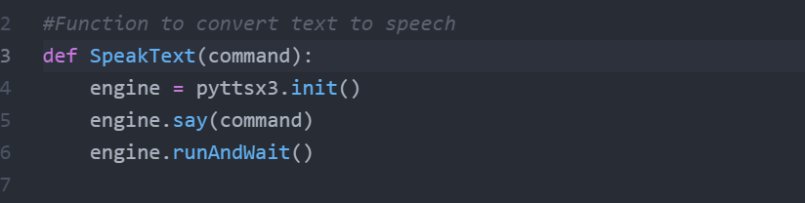

This method uses google API to convert Speech-to-Text

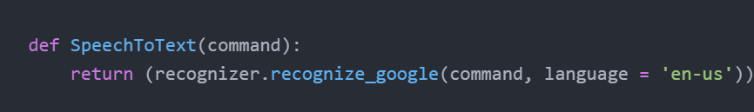

Below segment of code is used to send mail on particular mail Id. This uses Simple mail transfer protocol, MIMEMultipart and MIMEText to send html pages, files or plain text.

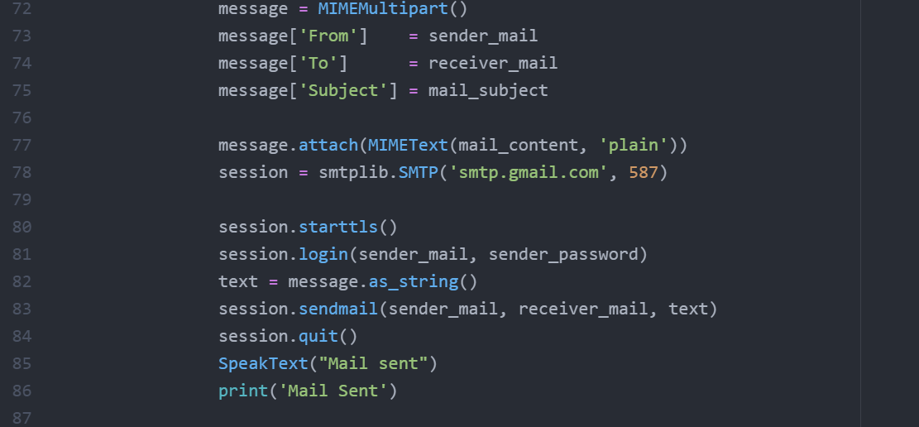

Below segment of code is to fetch mail from the inbox of user. This uses Internet mail access protocol to fetch the mails.

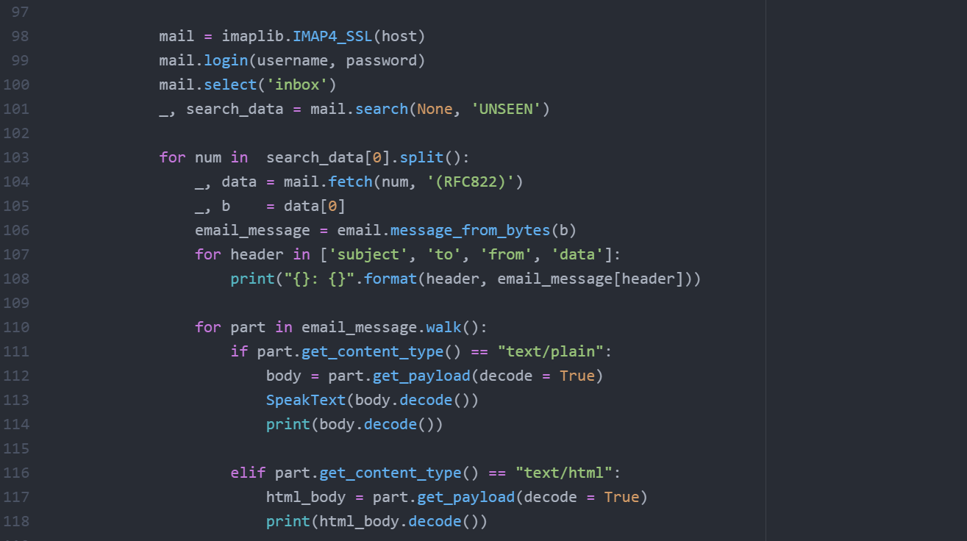

**1.11 Conclusion**

We have made a model that can help visually challenge people to send mail and read mails from there inbox by just taking the voice command and avoid the using of keyboard completely.